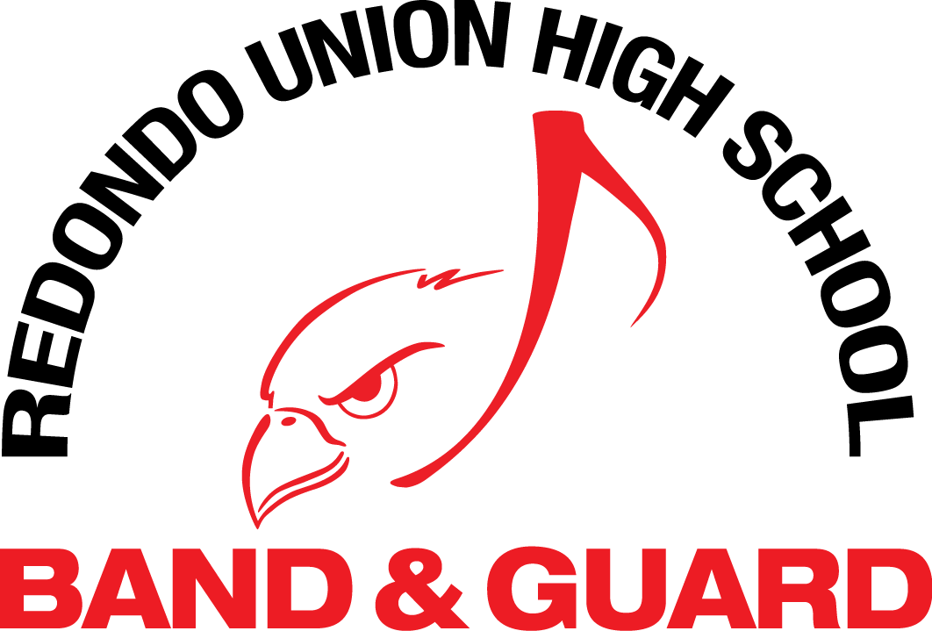
Band Mandatory Polo - ORDER FORM
(This shirt is uniform for first football game, Kelbo needs orders no later than Aug 8th)
Band Members Price Order/Size Paid
New members – Mandatory Polo Shirt (Red) $21.00 ______ $_________
Sizes: Youth L, XL, Adult XS to XL (these run really big. Most people order size smaller than normally worn!)
MONEY DUE AT TIME OF ORDER TOTAL PAID $_________________
STUDENT NAME: _____________________________________________
Parent/Guardian: _____________________________________________
Phone#: _______________________________________________________
Email: _______________________________________________________
MAKE CHECK PAYABLE TO: KELBO’S DESIGNS : E-Mail- kelbo8@aol.com 310-543-8776
Kelbo’s Designs C/O Tracey McMartin 609 S Irena Ave Redondo Beach CA 90277
Cash _____ Check ______ Check # _______ Date ________

